Significance section of an NIH grant application
  - a guide for developing a comprehensive first draft that tells a story

About this guide
Terminology: The purpose of any grant-funded project is to solve a problem that has evaded solution or fill an important gap in knowledge, a gap that is preventing the field from moving forward. For some types of projects, the wording ‘solve a problem’ is fitting. For other types of projects, ‘fill a gap in scientific or technical knowledge’, relieve a bottleneck’, ‘break down a barrier to progress’ or ‘develop a tool’ work better. Below, for brevity, I mostly use ‘solve a problem’.
Steps: Not all steps below are relevant for all types of studies; and information from some steps may end up being redundant with information from other steps. A reasonable approach is to respond to each prompt (to achieve comprehensiveness), then condense. The “/” marks typically denote different ways to think about the same concept. If an item doesn’t seem to apply to your project, skip it.
Flow of content: The NIH does not require that you follow their instructions in order, but the NIH instructions actually do follow a story format. So that’s how I organized the template below.
Context of your research: Writing Significance will be much easier if you have already thought about the context of your research project, using the “Context of my Research Project” worksheet.
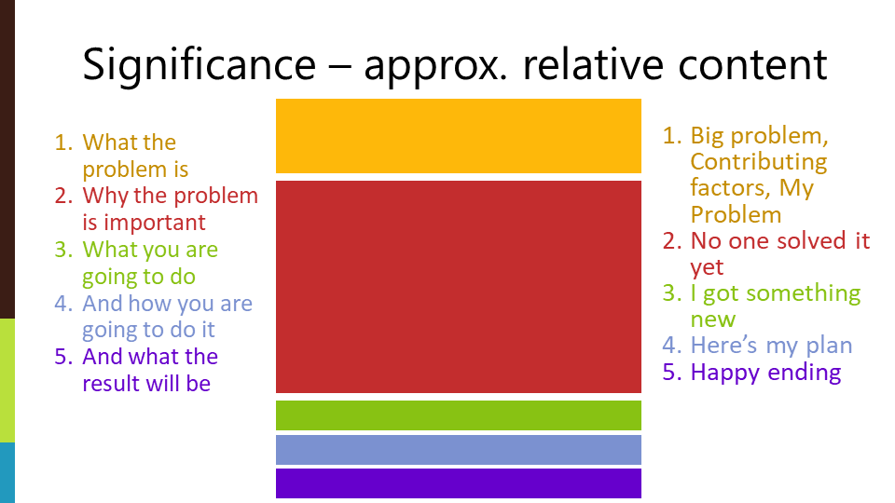
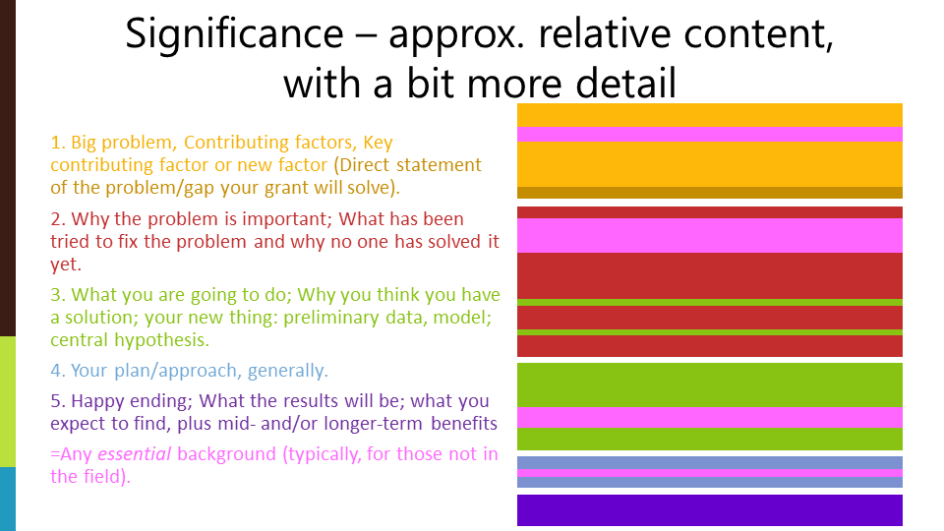

Writing Significance
Headings: Your Significance section should have some headings; maybe 5-8 of them. You can create whatever headings you think will best guide your reviewer. Try declarative sentences that spoon feed the reader your main take-home points. One point per heading; one heading per paragraph. Bold or underline these.
References: You certainly need to cite more than 10 references, but probably not as many as 100 (this is not a literature review). The sample applications made available by NIH cite ~30-50 references in the Significance section.
Length: Total length is commonly 1-1.5 pages for an NIH K application, 1-2 pages for an NIH R01 application (shorter if the audience is familiar with the work, longer if not).
I’ve organized this guide by NIH instructions for Significance (as of 12/16/22), but if this looks like your Grant Story it is! (NIH wants your story!)

NIH Instruction #1
Explain the importance of the problem or critical barrier to progress in the field that the proposed project addresses.
- What is the problem / critical barrier to progress / gap in scientific or technical knowledge that the project addresses?
  - State it. This ‘’problem’ will be a central challenge in your field, that lots of people care about. In the next section you will narrow down to the gap your work will fill; alternatively, if the audience is broad, you may need to start with a broader challenge and narrow that down to a central challenge in your field)
  - Define it, describe it, and/or, summarize it (sometimes it helps to think about answers to ‘who, what, where, when, why, how’).
  - Document it. Give some type of quantitative or qualitative data that describes the extent or scope of the problem or barrier.
- Why is this problem/barrier/gap important?
  - State why it is important for the NIH Institute / for public health / for your field. If the area was identified as a major research focus of an Institute/Center, you should probably cite that.
- What factors are causing or contributing to this central challenge/problem/gap? / Why is it occurring?
  - You might list a number of contributing factors, or simply state a key factor. (“A variety of conditions may ultimately lead to ...“ “ A key reason is…”) Important: The key contributing factor is likely the problem your proposed project will solve, or very closely related to the problem you will solve.
    - Justify why your grant will focus on the key factor you select (the justification can come from your prior work or the literature).
      - Note: Justifying why you are focusing on the factor you identify will help you to not oversell or undersell your project idea.
    - If you are proposing to investigate a factor that no one had investigated before, to justify why you are looking at this factor describe the emerging data that suggests that this novel factor is likely to be important.
  - Note: precisely how you structure this section varies widely among grants. One factor that probably influences how this section is structured is the type of project you are proposing, e.g., a project that improves a current approach, or a project that is a new way to address a known root cause, or a project that addresses an unappreciated root cause.
- Directly state the specific problem or specific gap in knowledge that your project will solve.
- What are the consequences of not filling the gap. Think about: What impact is the problem/gap is having on progress? What will happen (e.g. the symptoms & consequences) if not the problem/gap is not solved/filled? (“As a result, …”) Who does the problem affect? Why should the problem/gap be solved; and why now? What progress is being prevented by not solving the problem/filling the gap in knowledge.

NIH Instruction #2
Is the prior research that serves as the key support for the proposed project rigorous?
- What have people tried to fix the problem/fill the gap? You can think about:
  - Briefly identify the most relevant studies of others. It may be appropriate to identify important, related issues that haven’t yet been addressed. (“Several promising strategies have been developed to address …”)
- If your work is not intended to fix the key contributing factor, which part of it will your work fix?
- Why have the things that others have tried not worked? / Why does the main contributing factor continue to be a problem? / Why is a solution currently missing? e.g., was the previous work not the right type, not enough, didn’t have whatever resources you have now, failed to appreciate some important factor that is now known (“However…”).
- What has happened that makes you think you and your team have a solution? Important: your solution has to address or be related to the reason that other approaches have failed.
  - Describe why you think you have a solution. You might start this section by explaining how you came to realize the gap/problem exists (from your data and/or the literature). Or you might start by describing your current work, the work that leads to your preliminary data.
    - Note: Providing an explanation/justification/rationale of why you think you have a solution will help prevent you from overselling or underselling your idea.
  - Briefly describe/summarize your preliminary data or key findings.
    - Note: According to NIH, you may present your preliminary data in full here, however, most people choose to simply summarize their preliminary results in the Significance section and then fully describe the preliminary data in the Approach section.
- Your data should lead to a hypothesis you will test in the grant, so state it here. Grants often have one ‘central hypothesis’ and smaller hypotheses for each Aim, so, either here, or within point 4, you might state in which aim you will test which part of your central hypothesis. Sometimes the data suggest a Model, within which some aspects are known and some aren’t. If this is the case, describe the Model and make it clear what the unknowns are.
- Why is your team qualified to solve the problem/fill the gap? (This might be already clear from the citations of your own published work or references to data figures in the application.)

NIH Instruction #3
Explain how the proposed project will improve scientific knowledge, technical capability, and/or clinical practice in one or more broad fields.
- What are you going to do to fill the gap? Write this generally, save details for Approach.
- In which Aim will you solve which aspect of the Gap/Problem? (if not already clear)
- What do you expect to establish / what are your expected, direct outputs of the work?
- What are the short-term benefits to be derived from solving the problem or filling the gap, e.g., benefits to a scientific field, improvements in technical abilities, improvements to clinical practice, diagnosis, or treatment? You might include how your study differs from previous work and how its results will contribute to items listed in an RFA (request for applications).

NIH Instruction #4
Describe how the concepts, methods, technologies, treatments, services, or preventative interventions that drive this field will be changed if the proposed aims are achieved.
- What will change as a result of your work, i.e. which concepts, methods, technologies, treatments, services, or interventions will change? / What is the longer-term and/or broader impact of your work (think about what things your work can enable both mid-term and in the longer-term; think about how your work can influence other fields) / How will your contribution enable subsequent thinking and research, speed translation, and/or improve health (e.g. changes in treatment approaches)? (“As a result, our knowledge of . . . will be advanced by . .

